1.largest number:
#code:
import java.util.Arrays;
import java.util.Comparator;

class Solution {
public String largestNumber(int[] nums) {
// Convert integer array to String array
String[] asStrs = new String[nums.length];
for (int i = 0; i < nums.length; i++) {
asStrs[i] = String.valueOf(nums[i]);
}

// Sort strings using custom combination comparator in descending order
Arrays.sort(asStrs, new Comparator<String>() {
@Override
public int compare(String a, String b) {
String order1 = a + b;
String order2 = b + a;
return order2.compareTo(order1); // Reverse order for descending
}
});

// Corner case: if the largest number is "0", the whole number is "0"
if (asStrs[0].equals("0")) {
return "0";
}

// Build the final large number string
StringBuilder largestNumberStr = new StringBuilder();
for (String numAsStr : asStrs) {
largestNumberStr.append(numAsStr);
}

return largestNumberStr.toString();
}
}
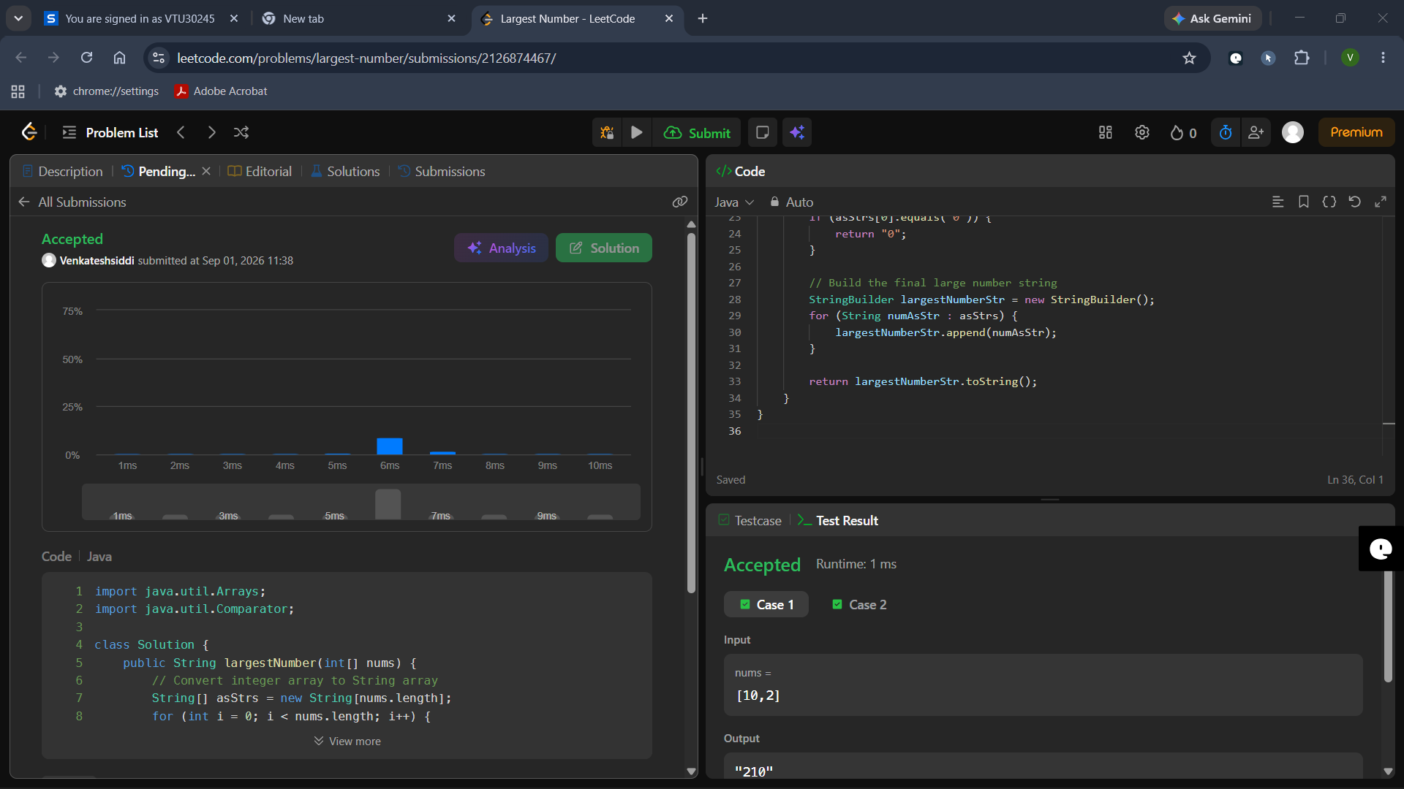

2. Java Comparator
#code:
import java.io.*;
import java.util.*;

// Write your Checker class here
class Checker implements Comparator<Player> {
@Override
public int compare(Player a, Player b) {
// Condition 1: If scores are unequal, sort by score descending
if (a.score != b.score) {
return Integer.compare(b.score, a.score);
}
// Condition 2: If scores are equal, sort by name ascending
return a.name.compareTo(b.name);
}
}

class Player {
String name;
int score;

Player(String name, int score) {
this.name = name;
this.score = score;
}
}

public class Solution {
public static void main(String[] args) {
Scanner scan = new Scanner(System.in);
int n = scan.nextInt();
Player[] player = new Player[n];
Checker checker = new Checker();
for (int i = 0; i < n; i++) {
player[i] = new Player(scan.next(), scan.nextInt());
}
scan.close();
Arrays.sort(player, checker);
for (int i = 0; i < player.length; i++) {
System.out.printf("%s %s\n", player[i].name, player[i].score);
}
}
}
